Wastewater Treatment Agencies of

Marin County

Public Education Program

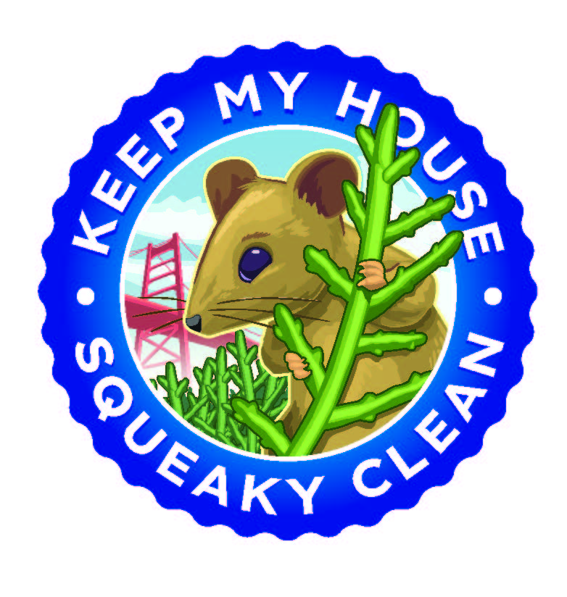
Central Marin Sanitation Agency – Novato Sanitary District – Las Gallinas Valley Sanitary District Sewerage Agency of Southern Marin – Sausalito Marin City Sanitary District – Sanitary District No. 5 of Marin County

Table of Contents
I. Introduction 4
II. Historical Summary 4
A. Copper 4
B. Mercury 4
A. Fats, Oil and Grease (FOG) 4
B. Public Education 4
III. Pollutants of Concern 5
IV. Sources of Pollutants of Concern 5
A. Copper 5
B. Mercury 5
C. Fats, Oils, and Grease (FOG) 6
V. Recent, Continuing, and Planned Tasks to Reduce Pollutants of Concern 6
A. Copper 6
B. Mercury 6
C. Fats, Oils, and Grease (FOG) 6
VI. Public Education Program Outreach 7
A. School Outreach 8
B. Outreach Booths 8
C. TV-ad (and YouTube) campaign 10
D. Website 10
E. Plant Tours 11
F. Brochures 11
G. Classroom Presentations 11
H. FastForward Publication 11
VII. Regional Efforts 11
A. STRAW 11
B. BAPPG 12
C. NBWA 12
D. BACWA 12
VIII. Evaluation of Program and Task Effectiveness Discussion 12
A. School Outreach 12
B. Public Outreach 13
IX. Summary of Programs Accomplishments and Future Plans 13
X. Appendices 19
Appendix A: 2022 Outreach Events 19
Appendix C: 2022 Public Education Brochures 22

Introduction
This report summarizes the Public Education Activities and measures for Pollution Prevention taken as part of the Wastewater Treatment Agencies of Marin County Public Education Program (Public Education Program). The Sausalito-Marin City Sanitary District (SMCSD), Las Gallinas Valley Sanitary District (LGVSD), Central Marin Sanitation Agency (CMSA), Novato Sanitary District (NSD), Sewerage Agency of Southern Marin (SASM), and Sanitary District #5 of Marin County (SD#5) are members of the Public Education Program. This annual report covers the reporting period of January 1, 2023, through December 31, 2023.

Historical Summary
Provided below is an historical summary over the last 5 years of the Public Education Program.

Copper
The Public Education Program has distributed brochures on how to control copper applications and discharges from pools, spas, fountains, plumbing practices, and demolition. These application brochures were mailed to plumbers, and demolition brochures mailed to construction companies in Marin County. These brochures were also made available in the typical outreach booth and various wastewater treatment facility reception buildings.

Mercury
Annual dental office inspections are performed in the service areas of CMSA, LGVSD, and NSD. These service area inspection programs have prevented Mercury amalgam waste from being released to the sanitary sewers. Additionally, the Public Education Program supports a Mercury Take Back program in which mercury thermometers are exchanged with digital thermometers during outreach events and at the wastewater treatment facilities.

Fats, Oil and Grease (FOG)
FOG inspections are performed in the service areas of CMSA, LGVSD, and NSD. These service area inspection programs have prevented FOG from being released to the sanitary sewers. Additionally, the Public Education Program actively supports a FOG prevention program by handing grease scrapers to be used in homes to scrape the grease off dishes prior to washing were also given away and are imprinted with an educational message.

Public Education
The Public Education Program has conducted several public outreach activities, including staffing an outreach booth at several local community events, coordinating in-school outreach shows, and hosting tours at treatment facilities.

Pollutants of Concern
A pollutant of concern is any toxic or undesirable substance that passes through a wastewater treatment plant or otherwise imposes undesirable operational costs to the Wastewater Treatment Agencies of Marin County.
In 2012 the Waste Discharge Requirements for Mercury and PCBs from Municipal and Industrial Wastewater Dischargers to San Francisco Bay (Regional Water Board Order R2-2022-0038) was adopted which contained Mercury discharge limits that apply to Publicly Owned Treatment Works (POTWs) in Marin County. Therefore, Mercury is a pollutant of concern for the Public Education Program.
Due to influent copper concentrations and NPDES permit limits for copper, copper is a current pollutant of concern for wastewater treatment agencies in Marin County. The Public Education Program has participated in activities geared toward reducing the discharge of Copper to the sanitary sewer from residents, plumbers, and pool and spa maintenance companies.
Discharge of fats, oils, and grease (FOG) to the sanitary sewer, alone or in conjunction with other factors, is a significant cause of sanitary sewer overflows (SSOs). The Public Education Program directed resources toward providing information to the public and business owners about reducing FOG discharge to the sanitary sewers.

Sources of Pollutants of Concern
Provided below is a list of the potential sources associated with the pollutants of concern identified by the Public Education program.

Copper
Listed below are identified or potential sources of Copper in Marin County. The list is based on available sample data, available references such as the Palo Alto Regional Water Quality Control Plant’s (RWQCP) “Copper Source Identification,” and best professional judgment.

- Water supply and plumbing corrosion
- Cooling towers
- Copper sulfate root killers
- Auto repair and related activities

Mercury
Listed below are identified or potential sources of Mercury in Marin County. The list is based on available sample data, available references such as the Palo Alto RWQCP’s “Mercury Source Identification,” and best professional judgment.

- Dental offices
- Residential Mercury disposal
- Photo processes
- Medical facilities
- Auto repair and related activities
- Human feces

Fats, Oils, and Grease (FOG)
Fats, oils, and grease (FOG) is produced by residential cooking operations, commercial food service establishments (FSEs), and industrial food production facilities. Although some collection system FOG-related issues have been reported in residential areas, most FOG issues are caused by FSEs.

Recent, Continuing, and Planned Tasks to Reduce Pollutants of Concern

Copper
In 2023, the Public Education Program handed out the brochure “Good Plumbing Practices Protect San Francisco Bay” and “Maintenance Tips for Pools, Spas, and Fountains” to homeowners and pool and spa maintenance companies.

Mercury
- Dental Amalgam Inspection Program: During 2023, LGVSD, CMSA and NSD service areas continued their annual dental office inspection programs to minimize the discharge of Mercury to the sanitary sewer from dental offices in Marin County. In 2023 amalgam separators removed approximately 34 lb. of Mercury within the service areas.
- Thermometer Take-Back Program: All partnered wastewater treatment agencies provided the service of exchanging Mercury-containing thermometers for digital thermometers at their offices for the public.
- Mercury Recycling Program: The Marin County Household Hazardous Waste Program is now accepting household hazardous wastes Tuesday thru Saturday instead of a one-time collection day event. Agencies continued to collect Mercury-containing devices, fluorescent tubes, ballasts, and batteries for proper recycling and disposal.
- Mercury Outreach Materials: Mercury disposal brochures produced by the EPA that discuss the toxicity of mercury and how to properly handle their disposal are handed out at all public education and outreach events.

Fats, Oils, and Grease (FOG)
The Public Education Program continues the FOG Outreach Program by handing out information at several public events describing ways to reduce discharge of FOG to the sanitary sewers. Grease scrapers to be used in homes to scrape the grease off dishes prior to washing were also given away and are imprinted with an educational message. On the outreach quiz there is a question about how to properly clean pots, pans, and dishes before washing that was answered by members of the public. Many of the FOG Control Programs of Marin County POTWs regulate FSEs. Multi-lingual posters were handed out and displayed at FSEs about proper handling, recycling, and disposal of FOG including grease trap maintenance. Laminated posters are available at the booths for the public to view. The program also hosts various educational sessions at Senior living facilities where FOG is one of the topics covered.
In 2023, seven outreach events were conducted by public education staff and the distribution of door hangers continued to reach a broader diversity of the community. Public outreach materials and door hangers consisted of assorted brochures:
- “Fat-Free Sewers”,
- “Wipes Clog Pipes”,

Public Education Program Outreach
In 2007, six Marin County POTWs--Central Marin Sanitation Agency (CMSA), Las Gallinas Valley Sanitary District (LGVSD), Novato Sanitary District (NSD), Sewerage Agency of Southern Marin (SASM), Sanitary District No. 5 of Marin County (SD5), and Sausalito-Marin City Sanitary District (SMCSD), implemented the Public Education Program. The educational activities of each Public Education Program member agency are enhanced by combining resources and sharing a unified message.
All the public outreach and school activities listed below and in Table 1 below are coordinated and administered through the Public Education Program. The public outreach activities listed below are designed to educate students and the public on the following issues:
- The difference between storm drains and sanitary sewers, and their functions.
- Nothing but rainwater should go in storm drains.
- The types of wastes appropriate for the sanitary sewers.
- “Flush Green” - the toilet is not a trash can.
- Ways to properly dispose of wastes that cannot go in the storm drain or sanitary sewers (e.g., household hazardous waste programs).
- Beneficial reuse of treated wastewater and biosolids.
- Hazards and proper disposal of waste Mercury.
- Issues relating to preventing FOG-related SSOs.
- Private sewer laterals, responsibility for their maintenance, and their potential to cause infiltration into the collection system which can lead to SSOs.
- Emerging topics are added to the Public Education Program when appropriate.

Table 1: Public Education Program Budget
Budget Line-Item Description | FY22-23 Budget _{a} | FY23-24 Budget _{a}
Event Enrollment (Booth costs) | $ 4,000 | $8,000
Juggler Show (20 shows per year annual cost) | $ 10,000 | $11,000
Fast Forward/Kidspeak Publication | $ 4,000 | $5,000
Logo Development (every other year) | $ 2,000
SAV-R-BAY website maintenance | $ 1,500 | $1,000
Booth Set Up Supplies (yearly events) | $ 1,000 | $1,500
Booth Technology equipment | $ 2,000 | $2,500
Brochures (printing/updates/ development) | $ 3,000 | $4,000
Public Education Video Outreach (Comcast) | $ 18,000 | $20,000
Promotional Items | $ 12,000 | $20,000
Marin Science & Environmental Leadership Program (MSEL) | $ 2,500 | $2,500
Total | $ 60,000 | $75,500
a. FY22-23, fiscal period from July 1, 2022, to June 30, 2023. FY23-24, fiscal period from July 1, 2023, to June 30, 2024.

School Outreach
The Public Education Program works with professional entertainers to produce the scripts for entertaining and educational school outreach shows. The shows address water and pollution issues in a simple, humorous manner suitable for kindergarten to sixth grade. The entertainers are then contracted to present the shows at schools in Marin County. For the 2021 school year, the Public Education Program through the efforts of the “Go With The Flow” producer, converted his in-person show to a virtual show. In 2022, there were 9 virtual shows, and 12 in-person shows. In 2023 all juggler presentations were in-person assemblies. In-person shows were presented to 19 Marin County schools reaching a total of 3,893 students.

Outreach Booths
The Public Education Program staffs outreach booths at several public events each year. Visitors to the booths have an opportunity to take a quiz concerning the topics listed above. Adults who answer all questions correctly win their choice of a t-shirt, stainless water bottle, stuffed animal, canvas tote, or nylon backpack bag. Children are given a simpler quiz addressing similar issues. If they answer all the questions correctly, they may spin a prize wheel. The quizzes are intended both to educate the people who take them and to provide information on the public’s level of awareness on key topics. In addition to administering quizzes, staff members engage the public and answer questions regarding pollution prevention, wastewater treatment, recycled water, and other environmental issues. At outreach events, staff has the opportunity to talk with local teachers and inform them of possible outreach activities including in class presentations and facility tours offered by the Public Education Program member agencies.
The following list includes a description of the events that were attended by the Public Education Program members during 2023.

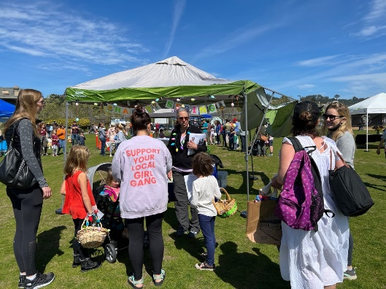
The Mill Valley Spring Eggstravanganza
On March 25, 2023, the Public Education Program participated in a community outreach event to educate the public on what not to flush. During this event, 350 individuals were engaged by public education staff on what not to flush down the toilet.

Novato Farmer’s Markets
The City of Novato sponsors Farmer’s Markets with vendors and entertainment in downtown areas. The Public Education Program staffs an outreach booth at the market on June 20, 2023. During this event 98 individuals were presented key public education topics.

The Marin Rotary Day of Service
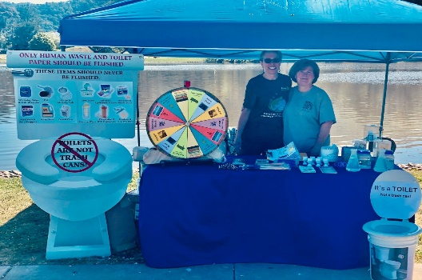
The Rotary Day of Service – Protecting the Environment was held at the Marin County Fairgrounds on May 13, 2023. The event featured local businesses and community members with expertise in sustainability. During this event, staff interacted with members of the public to discuss sustainability in the community.

Ribbon Cutting Ceremony for Coloma Pump Station Project
The Sausalito Marin City Sanitary District (SMCSD) held a Ribbon Cutting Ceremony for the completion of the Coloma Pump Station Project on April 18, 2023. An outreach table focused on key pollution prevention education messages. Event

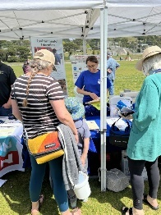
Mill Valley Earth Day
Mill Valley Earth Day on April 23, 2023, had speakers presenting a variety of environmental topics, research projects, studies, and success stories related to environmental concerns and potential impacts. It also had booths with local resources focusing on sustainability and conservation. During this event, 250 individuals were engaged by public education staff on the key aforementioned public education messages.

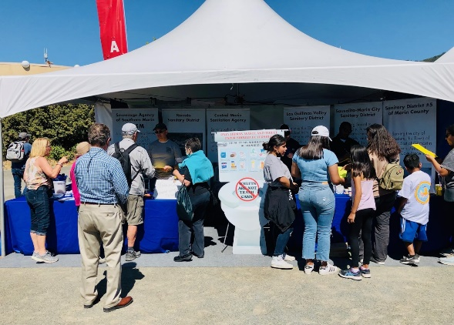
The Marin County Fair
From June 30th to July 4th, 2023, the Public Education Program staffed a community outreach booth to educate the public on key pollution prevention education messages. During this event, 1,229 individuals were engaged by public education staff on conservation and pollution prevention.

Get Ready to Go 94920
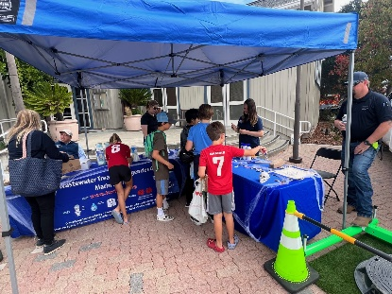
The Get Ready to Go 94920 event on October 14, 2023, was sponsored by the City of Tiburon. This event is where the public can view all the different First Responder Agencies and the equipment used in emergencies and disasters to 50 community members. Sanitary District No. 5 of Marin County showcased their equipment used in sanitary sewer spills. It was a chance to show the public what not to flush down the toilet and drains. During this event individuals were engaged by public education staff on key public education messages.

TV-ad (and YouTube) campaign
The Public Education Program partnered with Ross Valley Sanitary District (RVSD) to have TV ads covering specific topics (wipes, FOG, drugs) with all the district logos at the end of the ad to raise our collective visibility and show we are a unified, coordinated front. The ads ran on Effectv (Comcast) from March through June and again in November through December. Ads in the campaign included:
- “Do Not Flush Wipes”.
- “Proper FOG Disposal”.
- “Is Your Sump Pump Connected Properly?”
In 2023, during the first ad campaign, the ads were delivered 72,502 times within premium content and the target audience watched 65,418 (90%) of the ads in their entirety. During the second ad campaign the ads were delivered 132,783 times within premium content and the target audience watched 107,485 (81%) of the ads in their entirety.

Website
The Public Education Program launched the newly designed website www.savrbay.com on October 21, 2021. The website has information about what resources are currently available and activities and programs that are offered to schools and members of the community as well as the location and contact information for the six wastewater treatment plants in Marin County. In 2022 and 2023 quizzes at outreach events were taken online by using phones to scan the quiz QR code. Since 2022, 68 children’s quizzes and 104 adult quizzes were completed online. Since October 21, 2021, the website has been visited 17,706 times.

Plant Tours
Agencies conduct tours of the POTWs upon request from schools, community groups, and other members of the public.

Brochures
The Public Education Program has several brochures covering a wide range of topics including materials that should not be flushed, lateral maintenance, and copper. The brochures are regularly reviewed, and informational content is updated when necessary. This year several hundred brochures were distributed through door hanger outreach.

Classroom Presentations
Upon request from teachers, the Public Education Program provides presentations at school classrooms. Each presentation is tailored to the grade level of the class and generally covers the topics listed above. If requested, presentations can be tailored to focus on a specific area of study that is relevant to the teacher’s lesson plan. Each presentation has hands-on activities including looking at wastewater biology through a microscope, a watershed diorama, and a pollution-prevention-related video game.

FastForward Publication
The Public Education Program is a “Major Sponsor” for the FastForward school outreach publication. This magazine written by students covering a large array of subjects including media, arts, sciences, and current events. It gets distributed to over 50 elementary and high schools in Marin (including private schools) to a readership of over 25,000 students by print, and online it reaches an even wider audience, including teachers, administrators, and parents.

Regional Efforts

STRAW
The Students and Teachers Restoring a Watershed (STRAW) program coordinates and sustains a network of teachers, students, restoration specialists, and community members to plan and implement professional watershed restoration. STRAW provides teachers with resources, materials, and technical support to integrate watershed content into their classrooms. Environmental science education is delivered in coordination with other school science curricula throughout the school year. In 2023, the Public Education Program was not able to meet with STRAW teachers.

BAPPG
Public Education Program Members participate in the Bay Area Pollution Prevention Group (BAPPG). This is an excellent forum for local POTW Pollution Prevention staff to network and coordinate regional projects. The 2023 BAPPG Annual Report is available for download on the BAPPG website (bacwa.org) and includes descriptions of projects related to the following pollutants:

- Copper
- Fats, Oils, and Grease (FOG)
- Mercury and Silver
- Pesticides
- Pharmaceuticals
- Triclosan
- Trash and Wipes
- Fipronil / Imidacloprid / Pyrethroids

NBWA
Public Education Program agencies are members of the North Bay Watershed Association (NBWA). They participate in the NBWA Water Quality Committee through individual staff participation. The Water Quality Committee is of particular benefit to the Public Education Program.

BACWA
Public Education Program agencies are associate and affiliate members of the Bay Area Clean Water Agencies (BACWA). BACWA, the Bay Area Municipal Stormwater Collaborative (BAMSC), and the RWQCB have a Memorandum of Understanding for developing San Francisco Bay Total Maximum Daily Limits and SSOs and provide guidance and funding for receiving water monitoring through the Regional Monitoring Program and the San Francisco Estuary Institute.

Evaluation of Program and Task Effectiveness Discussion

School Outreach
The Juggler Show premiered in 2014 for grades 3-6 and was based on a similar show that was sponsored in 2004. Teacher feedback from the previous show was used when developing the current show. Evaluation forms are distributed to teachers after the presentation to determine the show effectiveness.
- Developmentally appropriate,
- Appropriate length,
- Adequately conveys the role that POTWs play in society to protect our water supply and the environment,
- Demonstrates the difference between storm drains and sanitary sewers,
- Any suggestions for improvement or additional information.
The completed forms are used to judge age appropriateness and other elements of the show. The 2019 production was revised and geared towards kindergarten to second grade level children. In 2020, due to COVID-19, the juggler show was revised to a virtual program. In 2021 due to COVID-19, the juggler show was viewed virtually with only a few in-person performances. In 2022, the juggler show was viewed virtually, and in-person shows returned to some locations. In 2023, all the juggler shows were in-person assemblies.

Public Outreach
The 2023 events are described in more detail above (Outreach Booth section). In normal years, quizzes are administered at public outreach booths at several events each year. Assessed solely based on the number of documented contacts with the public, the booths have been a very successful public outreach endeavor. There are many other useful means of contact with the public, in addition to people taking quizzes. It should be noted that whether a successful quiz-taker will exhibit desirable behavior regarding related environmental issues cannot be determined from test score data.

Summary of Programs Accomplishments and Future Plans
Copper Minimization Program
Goals | Reduce copper discharge to sanitary sewer from plumbing corrosion, pool, spa, and fountain maintenance and copper root control chemicals.
2023 Accomplishments | Brochures were provided to plumbers, pool, spa, fountain owners, and maintenance companies.
2024 Plans | Continue Public Education efforts through the Public Education Program.
Evaluation Criteria | The number of brochures handed out and questions answered by the public.
Mercury Dental Amalgam Program
Goals | Reduce mercury discharged to the sanitary sewer by implementing dental amalgam programs requiring amalgam separators.
2023 Accomplishments | Marin county dentist offices were monitored to ensure compliance. Approximately 34 lb. of mercury was collected from amalgam separators.
2024 Plans | Conduct detailed annual inspections in LGVSD, CMSA, and NSD service areas and determine program compliance of individual dental offices.
Evaluation Criteria | Track inspections compliance and ensure amalgam separators are maintained properly. Estimated amount of mercury captured is calculated based on amalgam hauled away and separator maintenance.
Mercury Take Back Program
Goals | Thermometer exchange program to exchange mercury-containing thermometers for non-mercury digital thermometers. Facilitate removal and recycling of mercury-containing products, including fluorescent tubes, ballasts, switches, bulbs, batteries, and laboratory chemicals.
2023 Accomplishments | Exchange mercury-containing thermometers for digital thermometers at POTWs. In 2023, 60 mercury-containing thermometers were exchanged. POTWs in Marin County recycled 28,964 ft. of fluorescent tubes; 233 lb. ballasts (PCB); and 32,916 lb. of batteries.
2024 Plans | Continue thermometer exchange at participating POTWs. Continue to properly recycle and dispose of mercury-containing fluorescent tubes, mercury-containing devices, and batteries. Hand out mercury disposal brochures at events.
Evaluation Criteria | Calculate the number of thermometers exchanged. Participating agencies will report on collection activity materials collected. The total combined amount of material collected is reported.
Fats, Oils & Grease (FOG) Program
Goals | Educate the public about minimizing residential FOG discharge.
2023 Accomplishments | Conducted several public outreach activities, including staffing an outreach booth at several local community events, coordinating in-school outreach show, and hosting tours at treatment facilities. Continued to distribute brochures with good practices related to pools, spas, fountains, and plumbing practices. Agencies supported TV commercial ads on the proper disposal of FOG.
2024 Plans | Continue the current FOG Outreach Program. Develop a new virtual outreach message and continue supporting RVSD’s TV commercial outreach for FOG and preventing SSOs.
Evaluation Criteria | Provided multi-lingual FOG outreach material to Marin County residents at outreach booths. Quiz questions, brochures, FOG scrapers, restaurant inspections are performed routinely by some agencies.
County-wide POTW Public Education Program
Goals | Unify public outreach efforts for all Marin County POTWs.
2023 Accomplishments | Maintained a combined program with 6 POTWs in Marin County.
2024 Plans | Continue the program and expand when beneficial.
Evaluation Criteria | Public Education Program topics and goals will be evaluated.
Marin County Public Education Website
Goals | Provide contacts and information on Public Education Program outreach program, Pollution Prevention, and contacts at POTWs.
2023 Accomplishments | Launched newly designed website, October 21, 2021. Updated all agencies’ website information.
2024 Plans | Continue to update and keep current the www.savrbay.com website. Update website with the new outreach ad campaign on wipes, FOG, and drug proper disposal.
Evaluation Criteria | Website traffic will be calculated.
“Wetlands Days” Program
Goals | Assist public agencies and non-profit organizations through the countywide Public Education Program during “Wetlands Days”.
2023 Accomplishments | Wetlands Days at the SASM facility were suspended in 2023 during a large capital improvement project.
2024 Plans | Resume Wetlands days in 2024.
Evaluation Criteria | Numbers of students and teachers who attend the event.
School Outreach Program
Goals | Provide educational entertainment to Marin County kindergarten to third grade students on wastewater, stormwater, and related Pollution Prevention topics that are revised every two years to target different age groups.
2023 Accomplishments | 19 ‘Go with the Flow’ Juggler shows were performed in 2023 reaching 3,893 students in kindergarten to third grade. All nineteen shows were in person, where 3,893 students attended.
2024 Plans | Continue newly reworked Juggler show.
Evaluation Criteria | Juggler show presented at local schools for younger children, kindergarten to third grade.
Public Outreach Program (Outreach Booths)
Goals | Educate the public through various outreach materials and provide one on one discussions on key Public Education messages between the public and agencies.
2023 Accomplishments | - Spring Eggstravaganza Event – Total of 350 visitors.  - Rotary Day of Service – 50 adults took quizzes. Total of 100 visitors.  - Ribbon Cutting Ceremony – Total of 25 visitors.  - Earth Day - Total of 250 visitors.  - Marin County Fair – 1,229 visitors.  - Farmer’s Market – 73 quizzes. Total of 98 visitors.  - Get Ready To Go 94920 – Total of 50 visitors.
2024 Plans | Promote appropriate Public Education Programs tailored to meet community needs.
Evaluation Criteria | The number of events attended, and quizzes given to the public.
Commercials for Wastewater Outreach on TV-ad & YouTube
Goals | Educate the public on proper disposal of unused pharmaceuticals and facilitate proper disposal. Educate the public not to flush “flushable wipes”. Educate the public on disposing of FOG.
2023 Accomplishments | In 2023, during the first ad campaign, the ads were delivered 72,502 times within premium content and the target audience watched 65,418 (90%) of the ads in their entirety. During the second ad campaign the ads were delivered 132,783 times within premium content and the target audience watched 107,485 (81%) of the ads in their entirety.
2024 Plans | Continue to support funding for TV ads on specific topics (wipes, FOGs, pharmaceuticals disposal). These ads will play for a 3-month term and twice per year.
Evaluation Criteria | Decrease of SSOs caused by FOG or wipes.
Websites
Goals | Provide outreach on District/Agency and Public Education websites.
2023 Accomplishments | The Public Education Program launched the newly designed website www.savrbay.com on October 21, 2021. Quizzes at outreach events are taken online by using phones to scan the quiz QR code. Since October 21, 2021, the website has been visited 17,706 times.
2024 Plans | Update website with relevant events and upcoming schedule.
Evaluation Criteria | Continue to monitor website traffic.
Plant tours
Goals | Outreach and education
2023 Accomplishments | In 2023, 530 students and adults toured POTWs countywide.
2024 Plans | Continue providing tours as allowed.
Evaluation Criteria | The number of people who toured Marin County POTWs.
Classroom Presentations
Goals | Teach students in a classroom setting about how agencies treat wastewater, what can and cannot go down the drains, and why.
2023 Accomplishments | Classroom presentations at Marin schools were not held in 2023.
2024 Plans | Continue to encourage schools to utilize the program and perform additional programs as requested.
Evaluation Criteria | Number of schools and students participating in the program.
Brochure
Goals | Develop brochures that effectively convey wastewater messages and Pollution Prevention to the public.
2023 Accomplishments | Brochures were handed out in limited quantities as door hanger packets. Additionally, brochures were reviewed, several were retired and noted brochures were marked to be reprinted.
2024 Plans | Develop some of our brochures in Spanish.
Evaluation Criteria | The number of brochures handed out.
FastForward Publication
Goals | Pollution Prevention Outreach to School-Age Children
2023 Accomplishments | “Major Sponsor” of the student magazine FastForward. These bi-monthly publications are delivered to 50 elementary and high schools in Marin (including private schools) for a readership of over 25,000 students. The magazine is also online and reaches an even wider audience.
2024 Plans | Continue to support and include the current logo.
Evaluation Criteria | Estimate how many students this publication reaches.
STRAW
Goals | Work with STRAW (Students and Teachers Restoring A Watershed).
2023 Accomplishments | Due to COVID-19, unable to partner with STRAW on wastewater-related Pollution Prevention activities.
2024 Plans | Continue to support STRAW.
Evaluation Criteria | The number of teachers and students receiving information on wastewater-related Pollution Prevention activities.
Bay Area Pollution Prevention Group (BAPPG)
Goals | Participate in SF Bay area regional Pollution Prevention planning & projects.
2023 Accomplishments | Participated in BAPPG.
2024 Plans | Continue membership and attend meetings.
Evaluation Criteria | See BAPPG Annual Report submitted to Regional Water Quality Control Board (RWQCB).
North Bay Watershed Association
Goals | Participate in watershed coordination, planning, and projects.
2023 Accomplishments | NBWA event will be held in 2023.
2024 Plans | Continue to participate in NBWA Water Quality Committee.
Evaluation Criteria | Engagement with NBWA.
Bay Area Clean Water Agencies (BACWA)
Goals | Facilitate SF Bay TMDL, SSO, regional studies development, and other regional planning/projects.
2023 Accomplishments | Associate member of BACWA (CMSA).  Affiliate member of BACWA (LGVSD, NSD, SASM, SD#5, and SMCSD).
2024 Plans | Continue membership.
Evaluation Criteria | Facilitate SF Bay TMDL, SSO, regional studies development, and other regional planning/projects.

Appendices

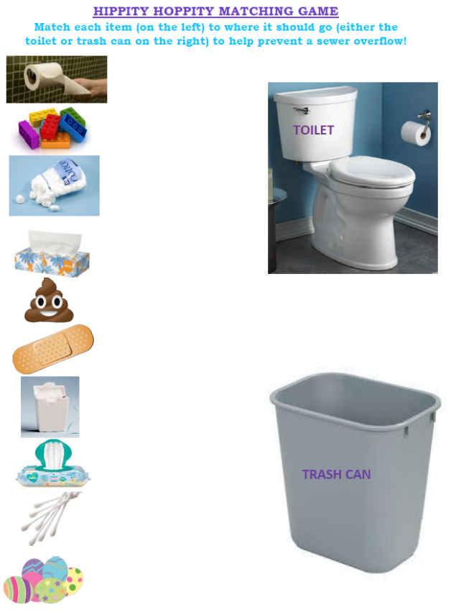
Appendix A: 2022 Outreach Events

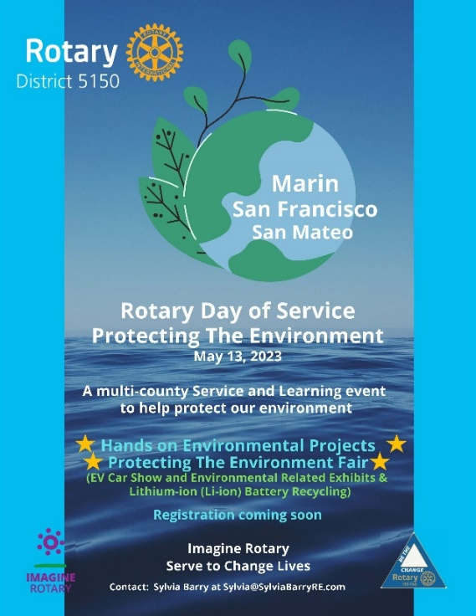
Appendix B: 2023 FastFoward Articles
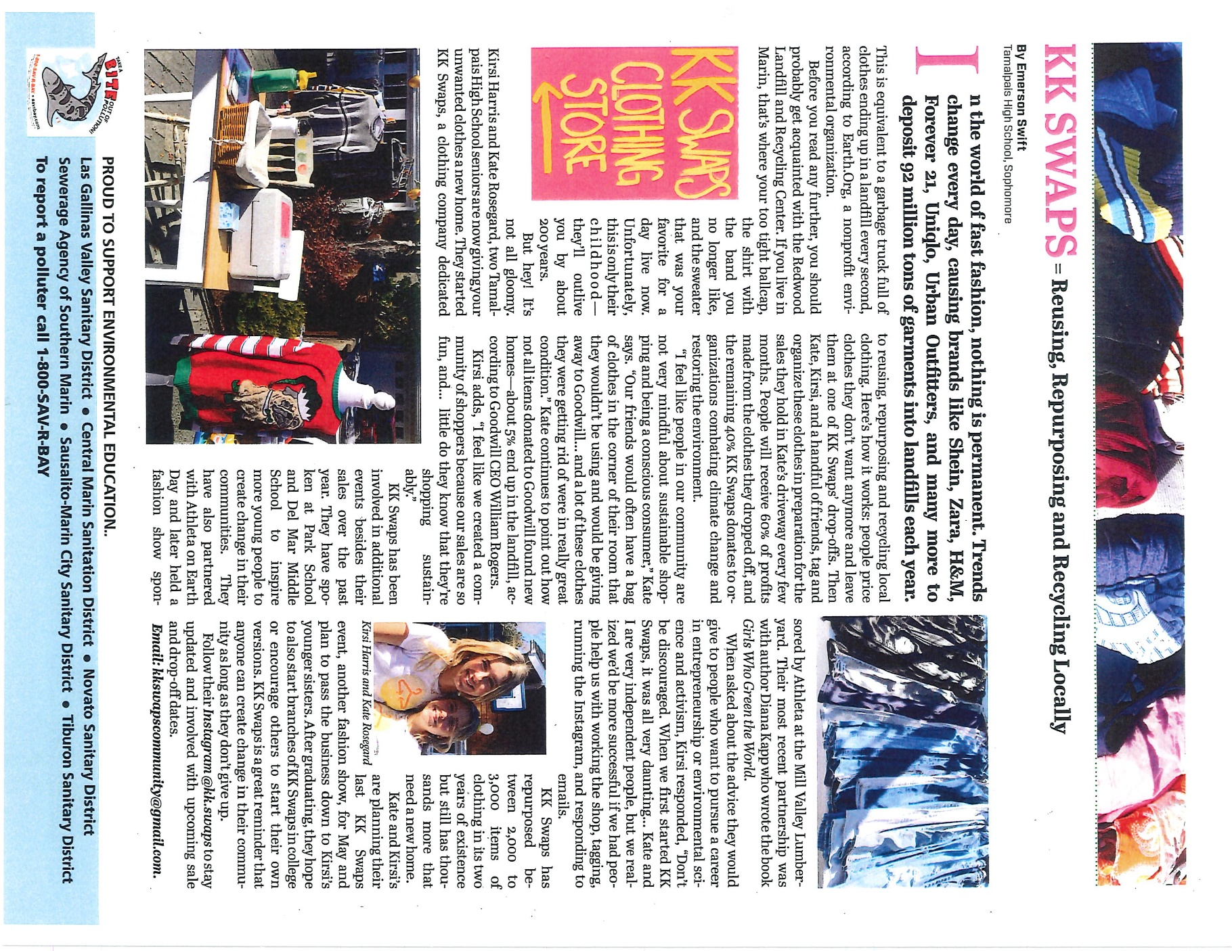

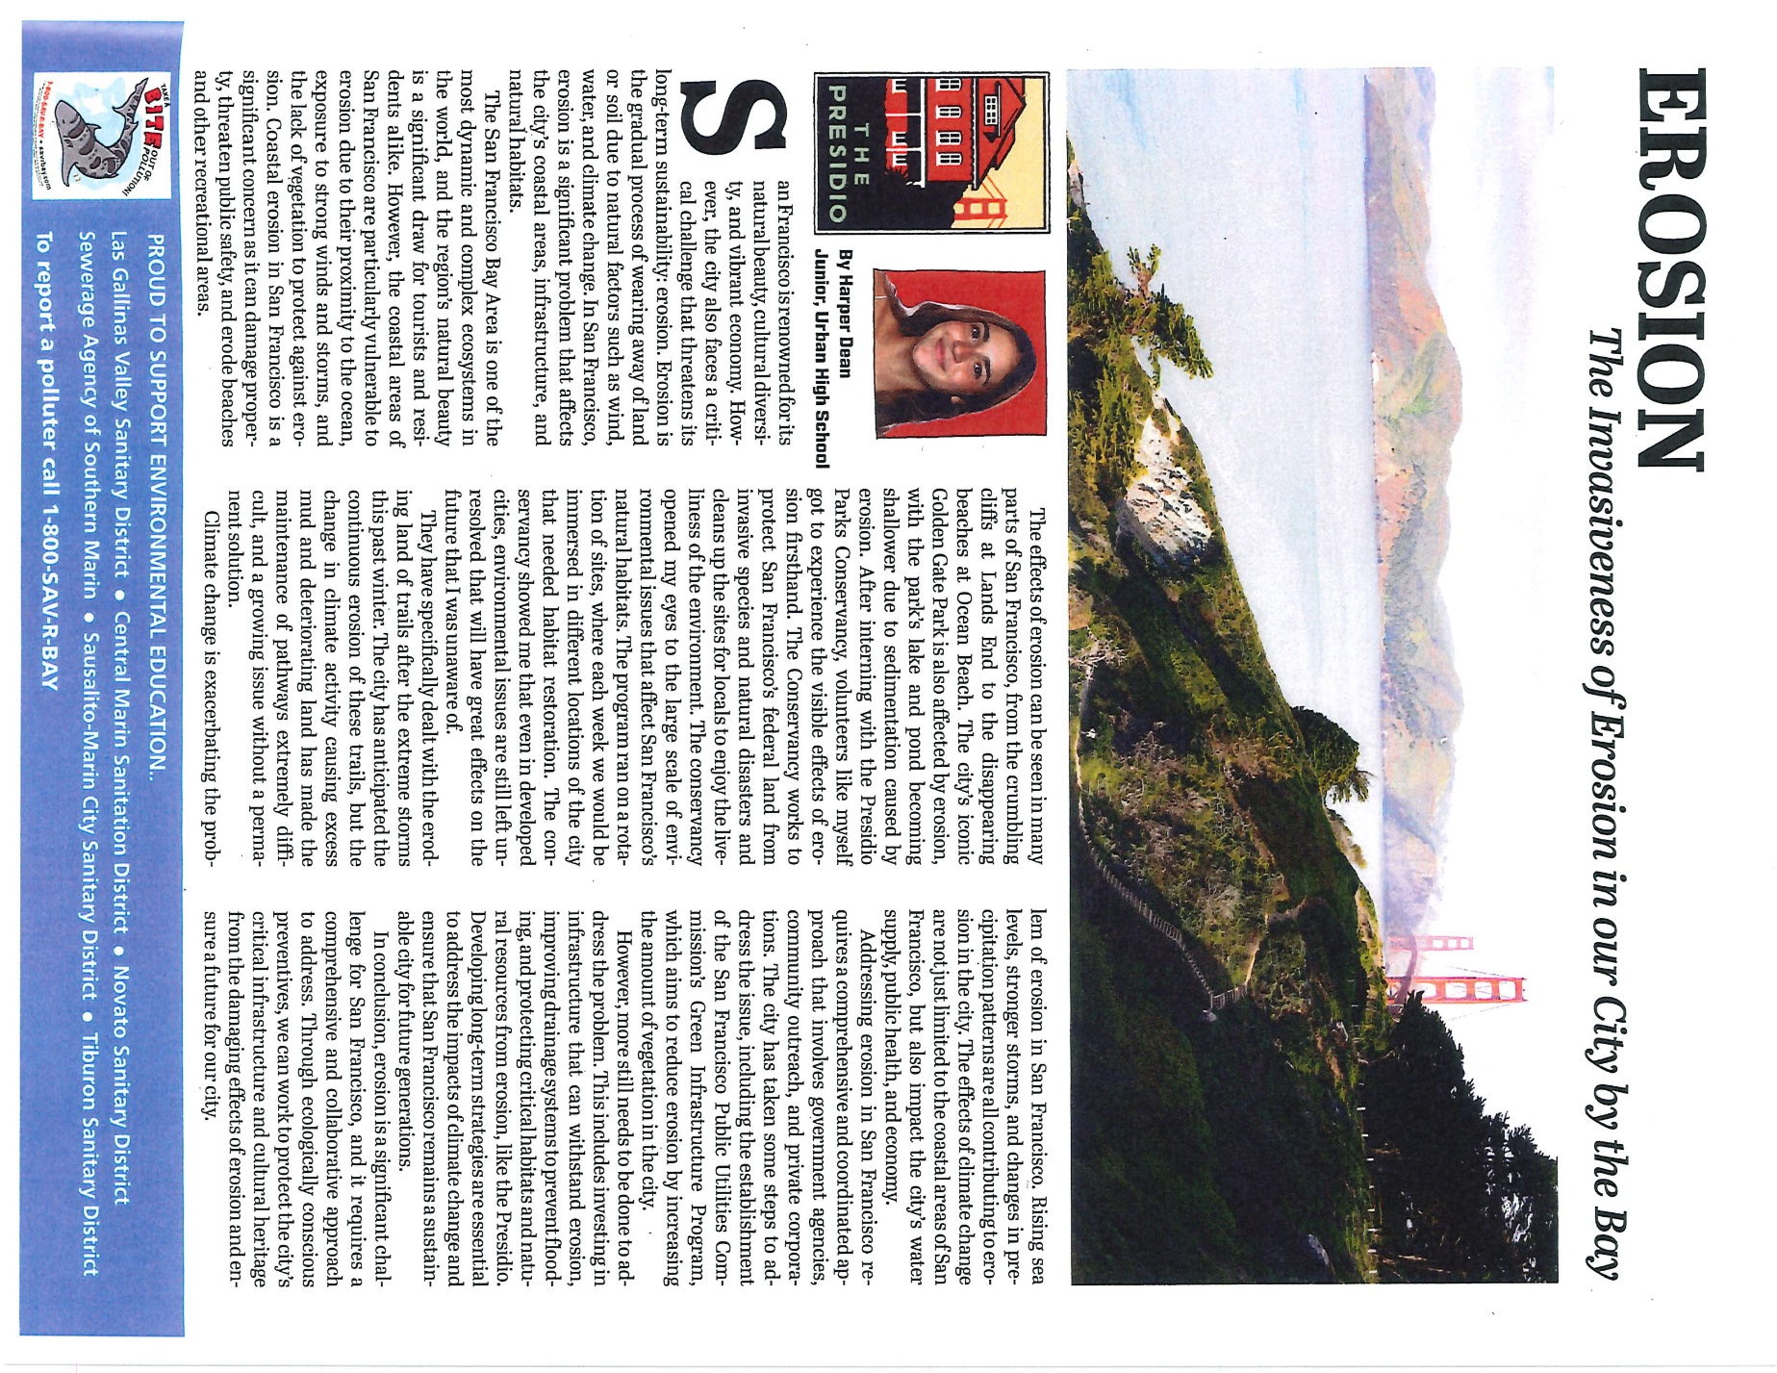

Appendix C: 2022 Public Education Brochures
